**USING RAPTOR – COUNT AND PRINT VOWELS IN GIVEN WORD**

**FLOWCHART**

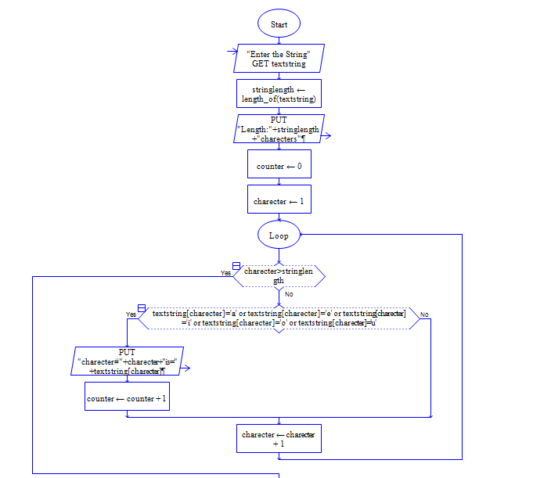



**OUTPUT**

INPUT IS vishnuvardhan

